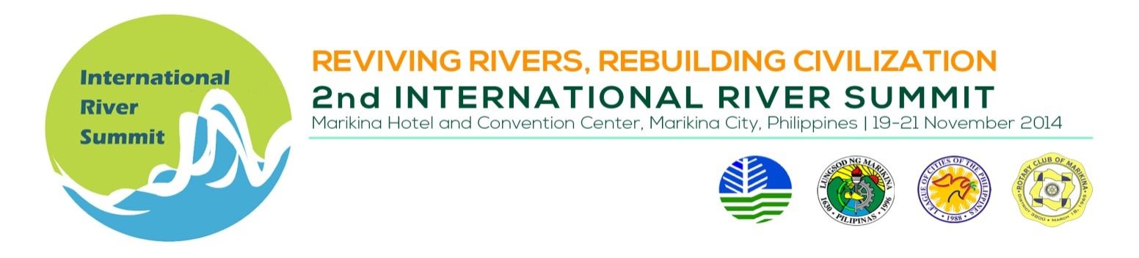
INDICATIVE PROGAMME

Thematic Session 6 : Water Partnerships, Convergence and Governance

Venue : Plenary Hall Convention Center

Date/Time : November 20, 2014, 1:30 – 5:00 PM

Session Chair : Engr. Rodora Gamboa, Chairperson, Philippine Water Partnership
Session Co-Chair : Mr. Oscar Parawan, Director, National Convergence Initiative

TIME | TOPIC | SPEAKER
 | SESSION INTRODUCTION | Engr. Rodora Gamboa
 | Cooperation and development in the Mekong River | Mr. Do Manh Hung, Deputy Director General, Institute for Water Development and Partnership, Vietnam
 | Inter-Local Government Partnership: Seven Rivers | Hon. J.R. Nereus O. Acosta, Presidential Adviser for Environmental Protection  and General Manager, Laguna Lake Development Authority, Philippines
 | Collaborative approach in sub-watershed governance: The Case of Tanay River | Hon. Rafael Tanjuatco  Mayor, Municipality of Tanay, Rizal, Philippines
 | BREAK
 | Inter-societal and multi-sectoral undertaking in Cagayan de Oro river basin | Most Reverend Antonio J. Ledesma, Archbishop  Metropolitan Archdiocese of Cagayan De Oro/ Chairman, Cagayan De Oro River Basin Management Council (CDORBMC), Philippines
 | Networking at Work: Network of Asian River Basin Organizations (NARBO) | Mr. Tadashike Kawasaki  Network of Asian River Basin Organization (NARBO), Japan Water Agency, Japan

